File Compare How to use

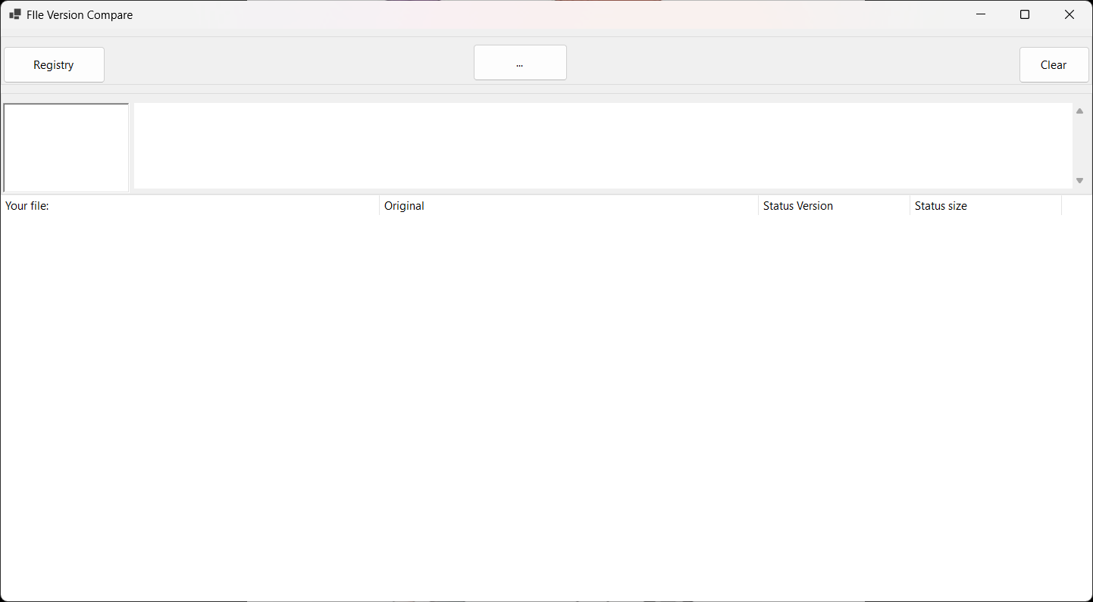

Above is the UI(User Interface) of the application File Compare. The first page is where you will compare exe files and the comparison information will be displayed there.

First click […] to open Explore folder where you will find the document which has the information you want to compare

Open your file json or txt.

-The first Box displays what is found inside your document(the one which has path written on)

-The second Box(largest box ) will display the compared information

\*Note when the color of text is gold it simply means the files does not exist

As for comparing version and file size : Green means a match and Red means mismatch

Then the next button Registry is used whenever the user wants to compare the registry settings

\*Note the registry file you will provide for comparison must be in text or json formats

This is the window you will see when comparing registry settings

Open the registry files which are to be compared

This is what you will see. As shown the application will compare the registry file you have provided with the registry settings on the your respective pc.